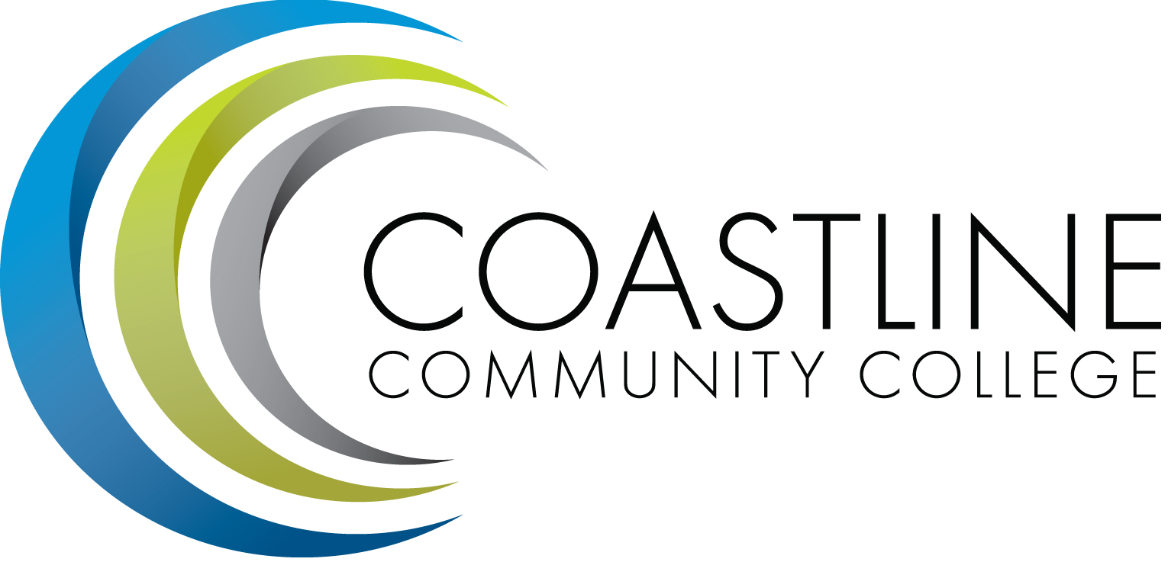

ACADEMIC SENATE
September 5, 2017 12:30 p.m. - 2:30 p.m.
College Center--Fourth Floor Conference Room
AGENDA
College Mission Statement: Coastline Community College steadfastly focuses on providing access and supporting student success and achievement. Inspired by an innovative and student-centered mindset, Coastline delivers flexible courses and services that cultivate and guide diverse student populations across the globe to complete pathways leading to the attainment of associate degrees, certificates, career readiness, and transfer to four-year colleges/universities.

12:30 p.m. 1. CALL TO ORDER: President Stephen Barnes
1.1 Pledge of Allegiance
1.2 Roll Call
1.3 Welcome
1.4 Adopt Agenda
1.5 Approval of Minutes –May 2, 2017 **
1.6 Consent Calendar
1.6.1 Approve TERC committees-see list**
1.6.2 Approve College committees-see list**
1.6.3 Approve Senate sub-committees-see list**

1.7 Public Comment and Statement: Members of the public can address the Academic Senators on any item that has been described in this notice, before or during consideration of the item. Persons wishing to make comments are allowed three minutes.

2. Welcome by College President, Dr. Lori Adrian

3. SPECIAL PRESENTATION
3.1 Ten Plus 1, Brown Act, and Roberts Rules of Order*-Ann Holliday, Stephen Barnes
3.2 Accreditation update-Danny Pittaway
3.3 Turn It In-Elizabeth Horan

4. ACTION ITEMS

5. DISCUSSION ITEMS
5.1 Professional Development Strategic Plan**-Senate Exec.
\ 5.2 Flex Day de-brief-Ann Holliday
5.3 Direction of College-Deborah Henry
a. Enrollment Management Plan-Draft*
5.4 Senate Goals-Stephen Barnes
a. Update Constitution and Bylaws**
b. Faculty Advising Structure
i. Guided Pathways
c. Faculty Handbook Update
d. Committee Reporting
i. Committee Report Form
e. Faculty Directory
i. Web Pages
5.5 Star Minimum GPA-Deborah Henry
5.6 Senate Meeting Time-Stephen Barnes

6. COLLEGE COMMITTEE REPORTS
6.1 PIEAC-Stephen Barnes
6.2 Budget-Rick Lockwood
6.3 Facilities-Michael Warner
6.4 Technology-Cheryl Chapman
6.5 Professional Development & Leadership-Lisa Lee
6.6 Student Success-Ann Holliday
6.7 Curriculum-Dan Johnson

7. SENATE SUBCOMMITTEE REPORTS
7.1 Academic Rank-Michael Warner
7.2 Academic Standards-Ann Holliday
7.3 Budget-Ann Holliday
7.4 Communications-David Lee
7.5 Elections-Margaret Lovig
7.6 Faculty Recognition-Ann Holliday
7.7 FSC-Rick Lockwood, Cheryl Chapman
7.8 Policy and Procedures-Deborah Henry
7.9 Social-David Lee

8. ANNOUNCEMENTS: (1-minute limit – please sign list to speak)

2:30 p.m. 9. ADJOURNMENT

*Hand-outs available at meeting.
**Copies have been sent to Senators. Others who would like a copy should contact the Senate office at academicsenate@coastline.edu.
Refreshments
Marilyn Fry, Deborah Henry, Ann Holliday, Lisa Lee
INFORMATIONAL HANDOUTS

- Draft minutes May 2, 2017
- Senate Sub-Committees 2017-18
- FT Faculty Committees 2017-18
- Professional Development Strategic Plan
- Draft Enrollment Management Plan 2017-20
- Senate Constitution
- AS By-Laws May 1, 2012
- TERC Assignments 2017-18 Revised
- Draft Committee List 2017-18

Next meeting: September 19, 2017.

Contact the Senate Office ~~ We welcome your input!
Stephen Barnes (714) 241-6156 ~~ Email: academicsenate@coastline.edu
Academic Senate Website: http://www.coastline.edu/academicsenate/
Zoom Link: https://zoom.us/j/619853943

